**EXPERIMENT:21**: **Date:18.03.24**

**Aim:** To Demonstrate Storage as a Service (SaaS) create and configure a new VM Image in any Public Cloud Service Provider

**Implementation:**

STEP:1:: open azure and create account Go to resource groups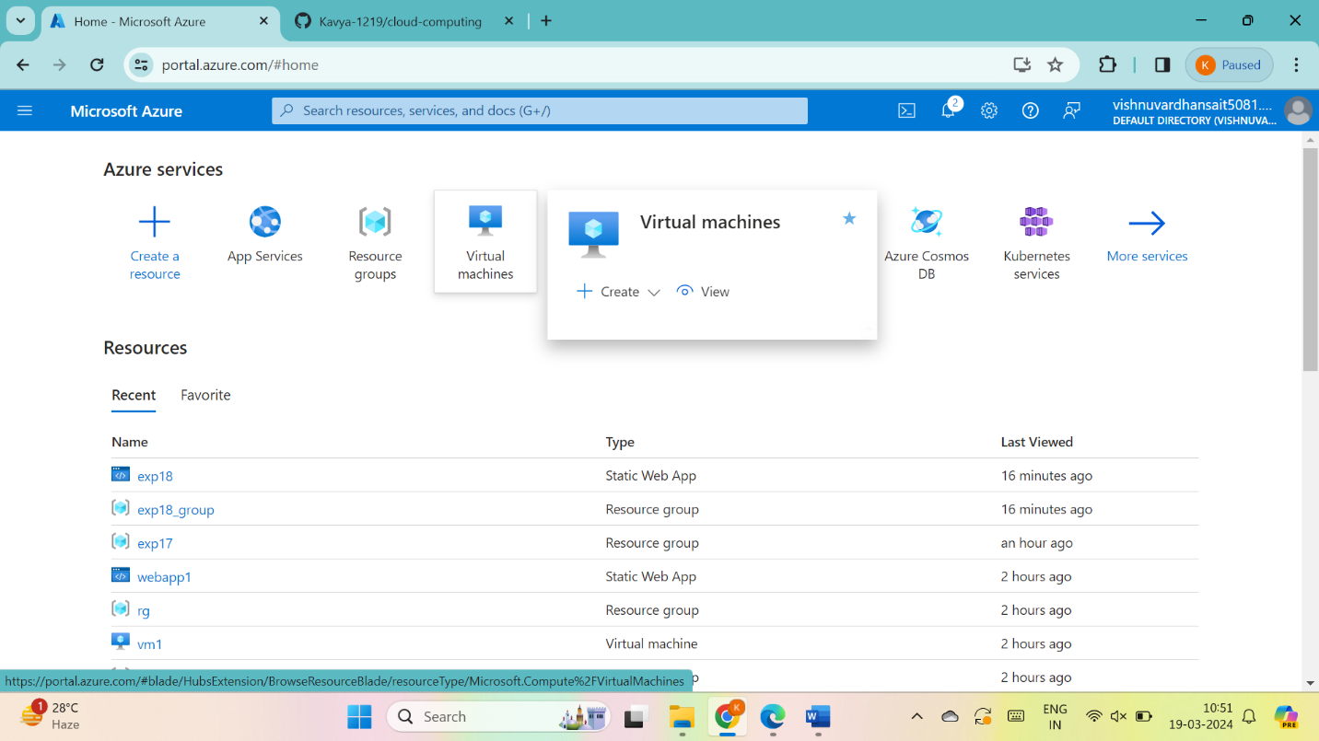THEN GO THE CREATE THEN AZURE VIRTUAL MACHINES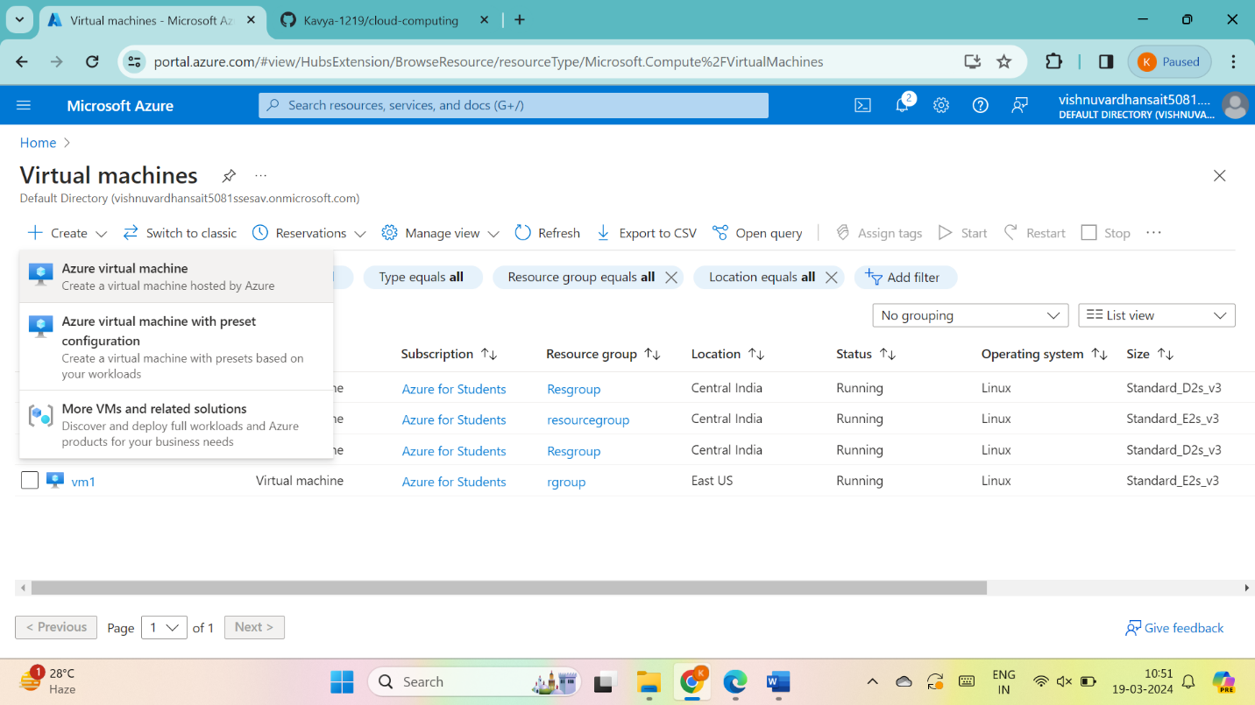

Give name to VM and give next : disks>

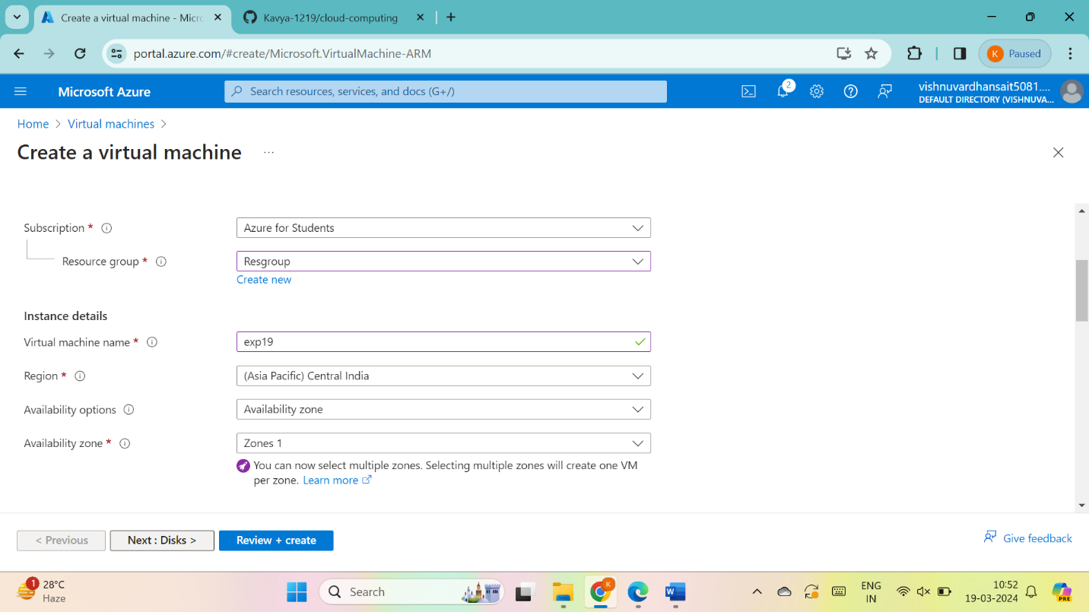

give next : networking>

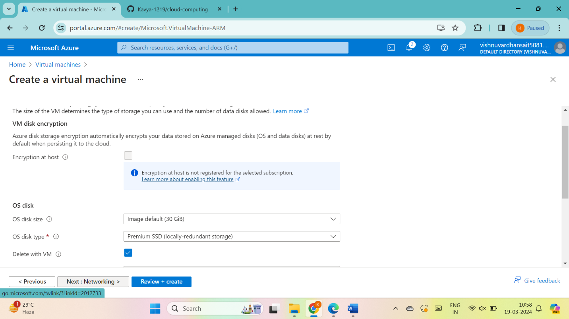

give next : management>

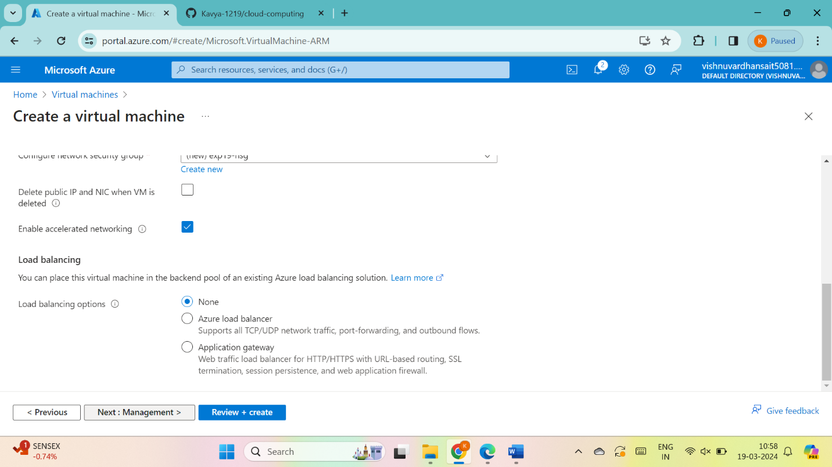

give next : monitoring>

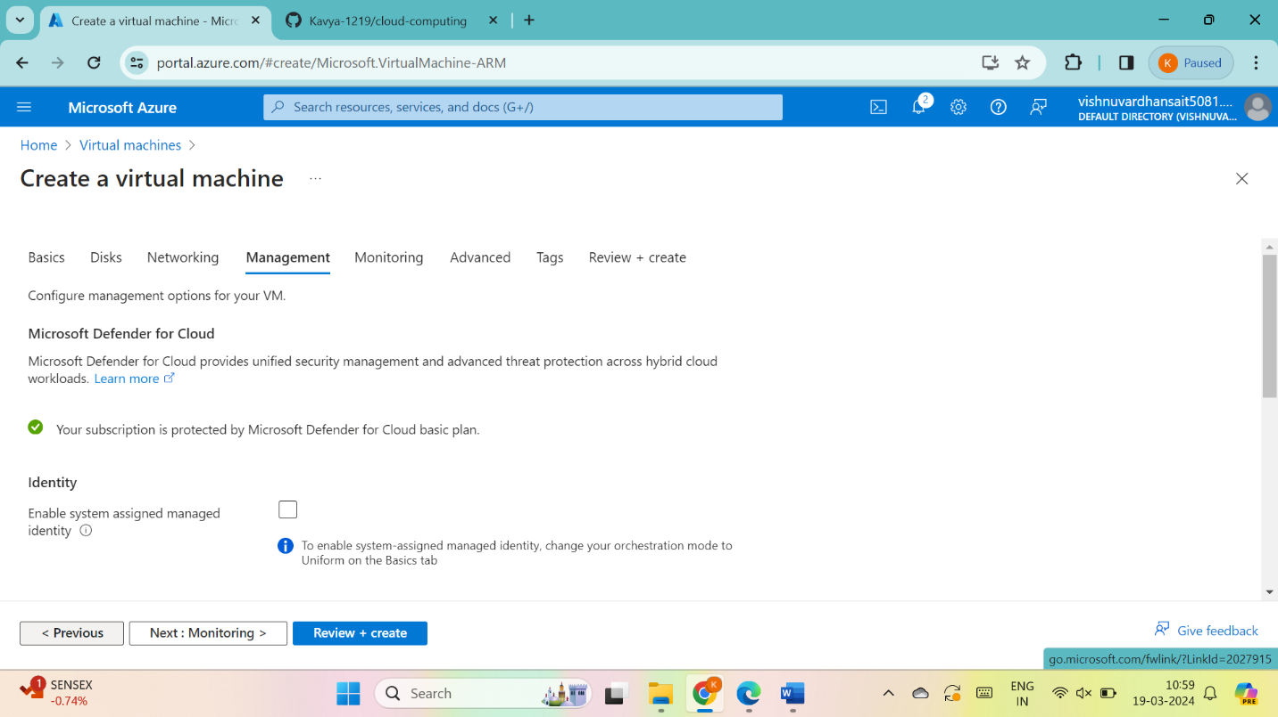

give next : advanced>

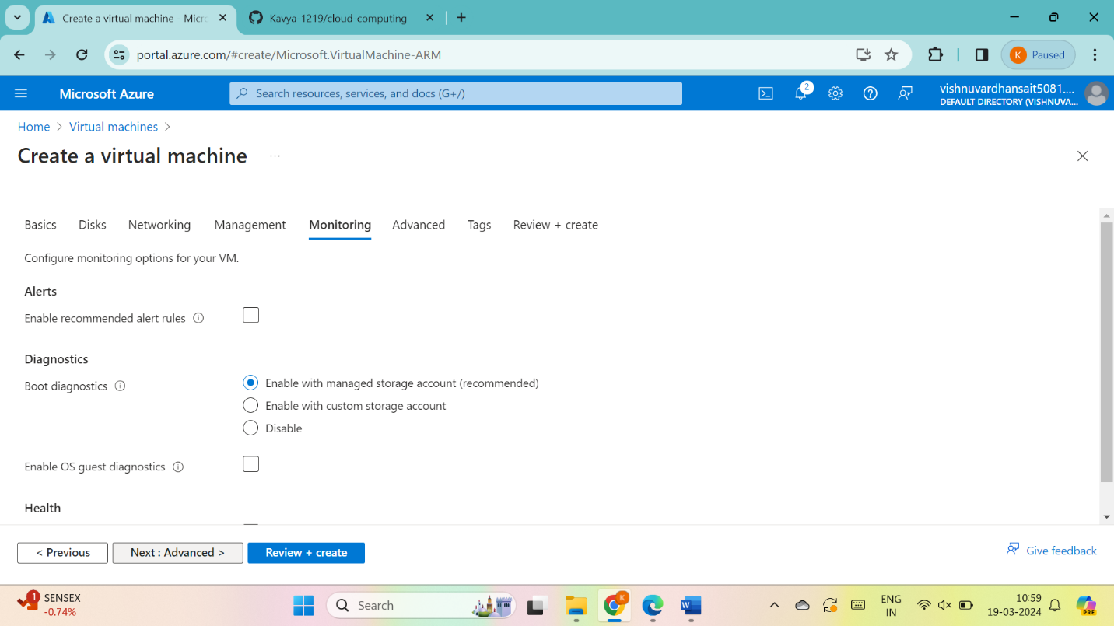

give next :tags >

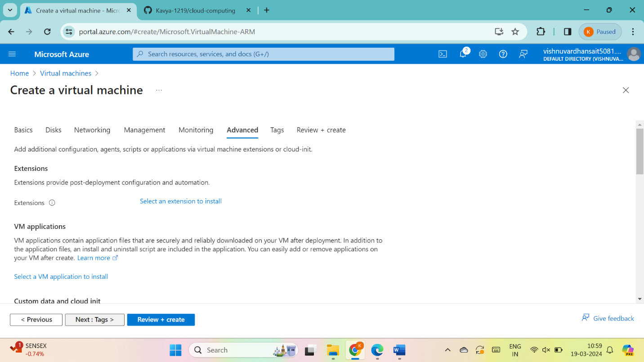

Fill details, give next : review + create>

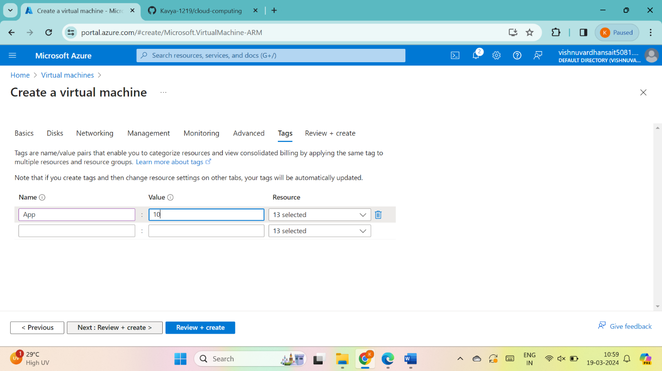

Now go to create

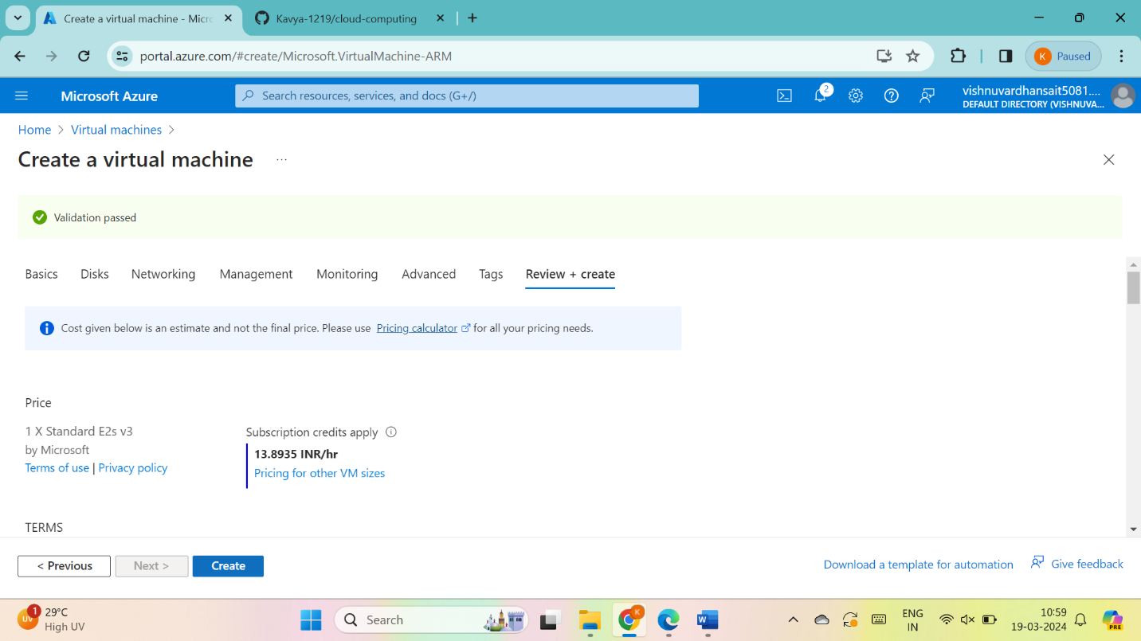

Go to download private key and create resource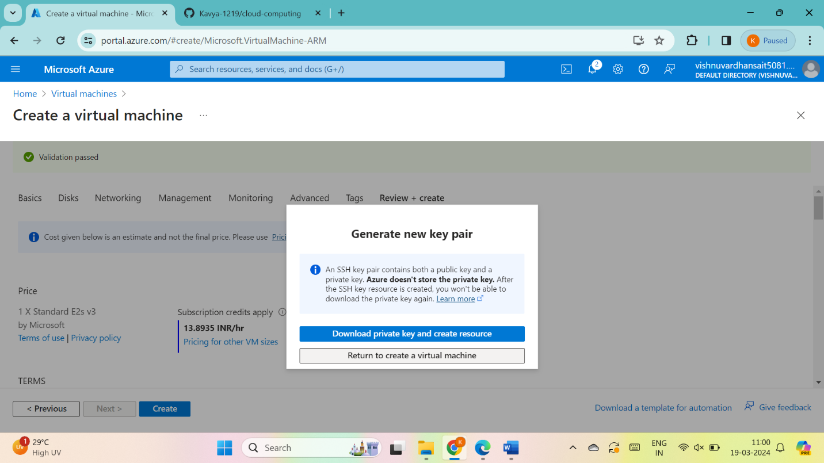

RESULT : THUS ,THE PROGRAM HAS BEEN EXCEUTED SUCCESSFULLY.

